­­

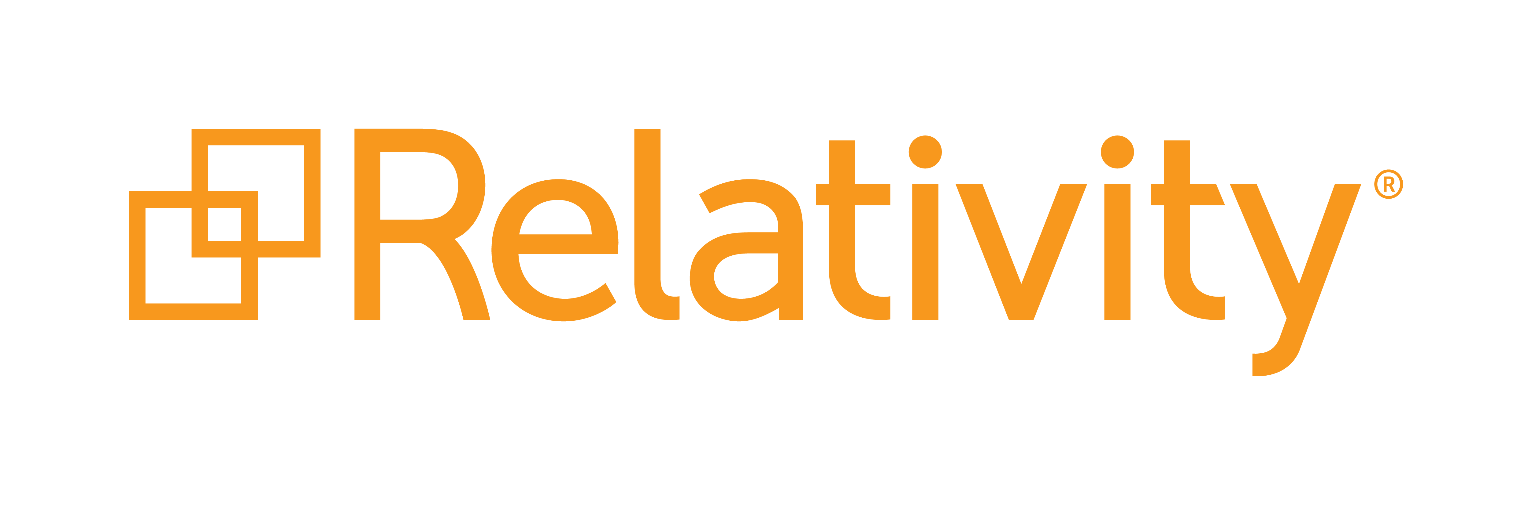

**Fest 2018 Workshop**

**Building Applications for Relativity and RelativityOne**

September 14, 2018 - Version 1.0

Contents

1 Course Overview 3

1.1 What You’ll Learn 3

1.2 Required Development Software 3

2 Getting Started 4

2.1 Workshop Projects 4

2.2 DevVM Setup 5

3 Starting Development 9

3.1 Application Set Up 9

3.2 New Event Handler 12

3.3 Publish 17

4 Sample Application Overview 22

4.1 Install Sample Application 22

4.2 Run Sample Application 24

5 Unit Tests 27

5.1 Writing Unit Tests 27

5.2 Running Unit Tests 32

6 Integration Tests 34

6.1 Writing Integration Tests 34

6.2 Running Integration Tests 37

6.2 Running Integration Tests as CI 39

7 Gravity API 44

6.1 Writing Integration Tests 44

1. Course Overview

As a developer, you want a solid process for building and testing your apps, so you can focus on delivering value quickly. The Application Deployment System (ADS) is the standard way to build applications on the Relativity platform. Relativity Test Helpers is our new, open source testing framework.  
  
In this advanced session, we'll review both of these standard approaches, covering common patterns for setting up effective ADS development solutions and integration tests. Topics will include: setting up your development environment using DevVM's; Visual Studio developer tools including templates, NuGet packages, and the "publish to Relativity" extension; and GitHub open source solutions such as Gravity, Test Helpers, and more. We'll also highlight ways to ensure your applications make a smooth transition from the on-premise world to RelativityOne. You will create tests and learn how to run those test from scripts as well as gain practical experience writing tests and potentially automating tests for your solutions, ensuring your customization will be ready run with the latest release of Relativity and RelativityOne.

* 1. What You’ll Learn
* Faster Development
* Publish to Relativity
* Logging
* How to Override New Button Link for a RDO
* How to Override Edit Link for a RDO
* Publish to Relativity Console
* Visual Studio Post-Publish Event
* Object Manager API
* Gravity API
* Unit Tests
* Versioning

1.2 Required Development Software

This workshop and associated development resources require a development environment that includes the following items:

* Relativity 9.5
* Visual Studio 2017
* Relativity Visual Studio Templates
* .NET Framework 4.6.2
* SQL Server 2012

We have provided the required software for you for this workshop.

1. Getting Started

2.1 Workshop Projects

1. Make sure you have a folder shortcut on Desktop with name **ads-workshop-fest-2018**.

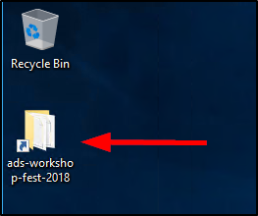

1. Double click on the **ads-workshop-fest-2018** folder to open it. Make sure you see the files as shown in the below screenshot.

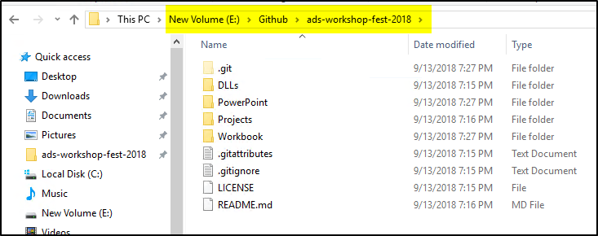

1. Go to the **Projects/Starting** folder to make sure you see the folders as shown in the below screenshot. These folders contain Visual Studio projects for different sections in the workbook.

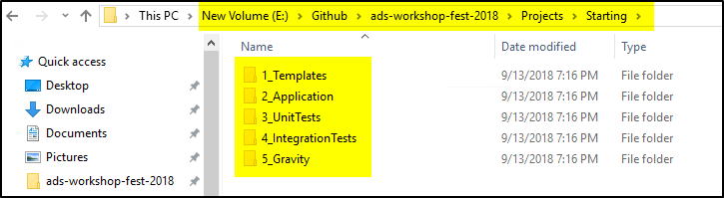

2.2 DevVM Setup

1. Open the **Hyper-V Manager** application by clicking the blue icon in the taskbar.

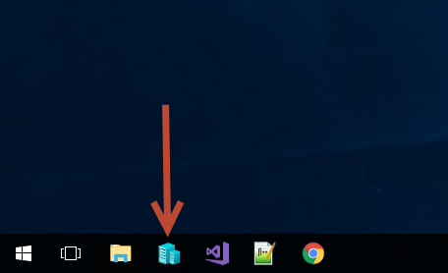

1. You will see a **Relativity 9.6.134.78 DevVM** listed in the Hyper-V Manager **Virtual Machines** section.

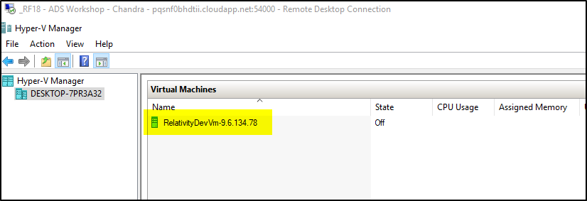

1. Right click on the **DevVM** and select the **Start** option.

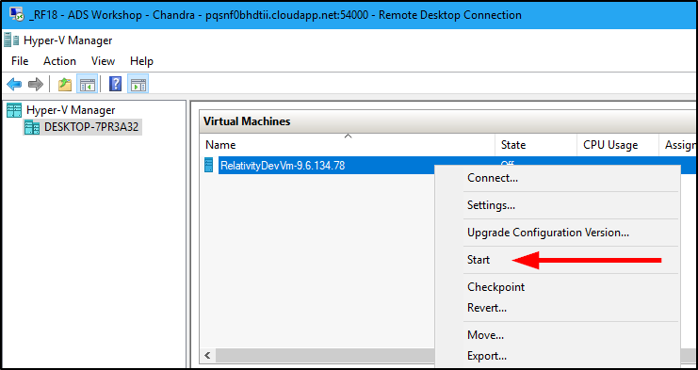

1. Right click on the **DevVM** and select the **Connect** option.

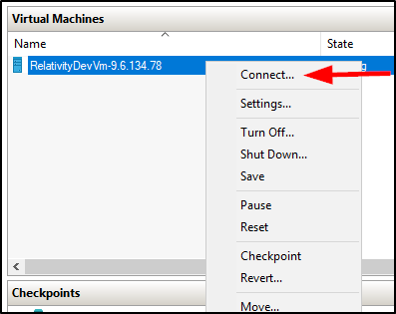

1. If you get a Display configuration pop-up, click the **Connect** button.

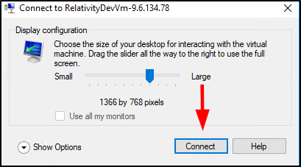

1. Select the **Action** Menu item and then select **Ctrl+Alt+Delete** option.

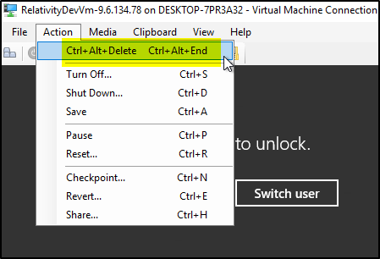

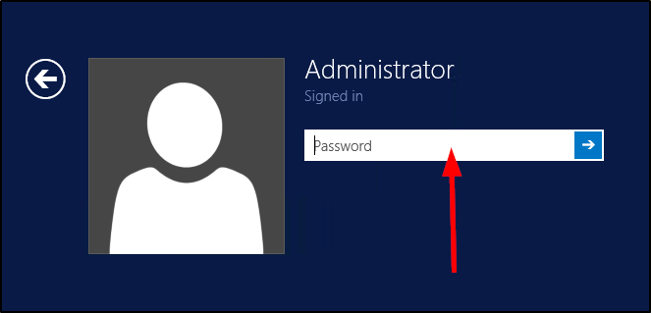

1. Use the below DevVM credentials highlighted in yellow to login to the VM.

**DevVM:**

Windows Admin login: Administrator

Windows Admin password: Test1234!

**Relativity:**

Admin login: relativity.admin@relativity.com

Admin password: Test1234!

**SQL:**

login: eddsdbo

password: Test1234!

Admin login: sa

Admin password: Test1234!

1. Once you log in to the DevVM, you should see the Desktop with few applications pinned to the taskbar, which you will be using throughout the workshop.
2. Click on the **Services** program icon  in the taskbar as shown in the below screenshot.

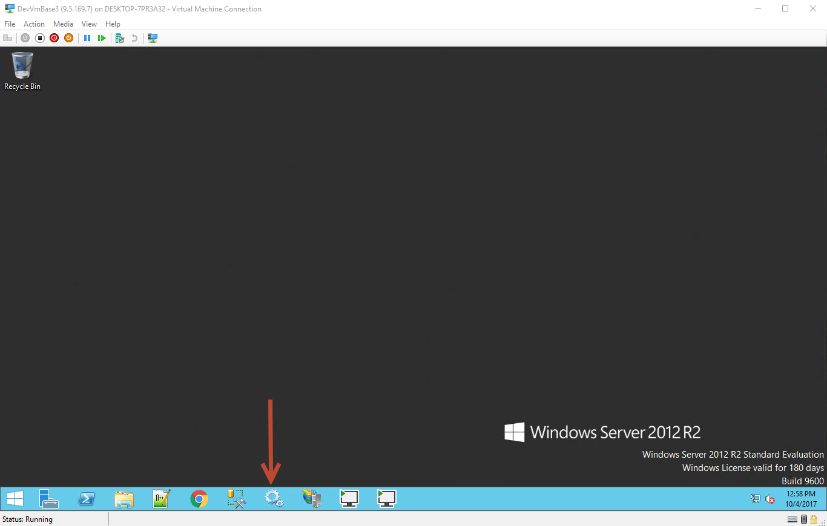

1. Make sure all the **services** listed below are **running**. If they are not already running, right click on the service and select the **Start** option,

* Service Bus Gateway
* Service Bus Message Broker
* Service Bus Resource Provider
* Service Bus VSS
* kCura Service Host Manager
* kCura EDDS Web Processing Manager
* kCura EDDS Agent Manager

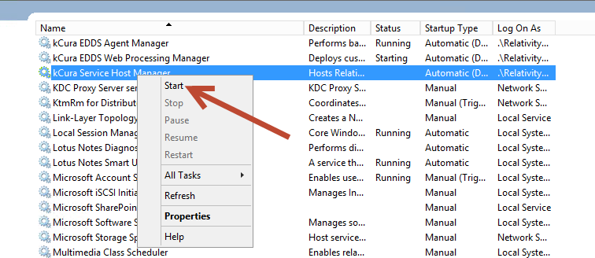

1. Open **Chrome** on your Workshop machine (Not the DevVM) and go to [**http://RelativityDevVm/Relativity**](http://RelativityDevVm/Relativity). Use the below Relativity admin credentials to login. Verify that you can login to Relativity.

**Relativity:**

Admin login: relativity.admin@relativity.com

Admin password: Test1234!

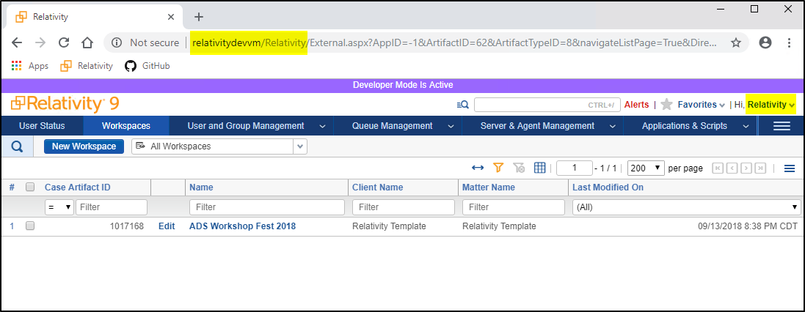

1. Starting Development

Relativity is an extensible platform that allows an administrator/developer to create customizations. Development on the Relativity Platform is made easier with the use of some tools such as Visual Studio Templates and the Publish to Relativity GUI. This section demonstrates utilizing the visual studio templates and Publish to Relativity tool to quickly iterate on application development.

3.1 Application Set Up

1. Open **Chrome** on your Workshop machine (Not the DevVM) and go to [**http://RelativityDevVm/Relativity**](http://RelativityDevVm/Relativity). Use the below Relativity admin credentials to login.

**Relativity:**

Admin login: relativity.admin@relativity.com

Admin password: Test1234!

1. Enter [**ADS Workshop Fest 2018**](http://relativitydevvm/Relativity/RedirectHandler.aspx?defaultCasePage=1&AppID=1017168) and navigate to the **Relativity Applications** Tab.

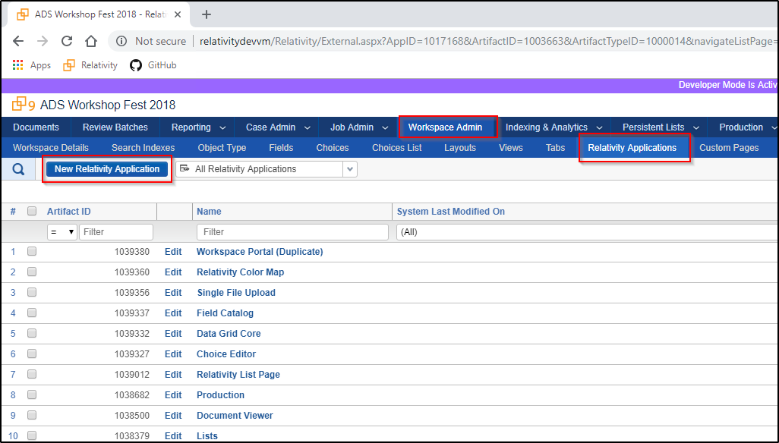

1. Create a new **Relativity Application** with the name of your choice.

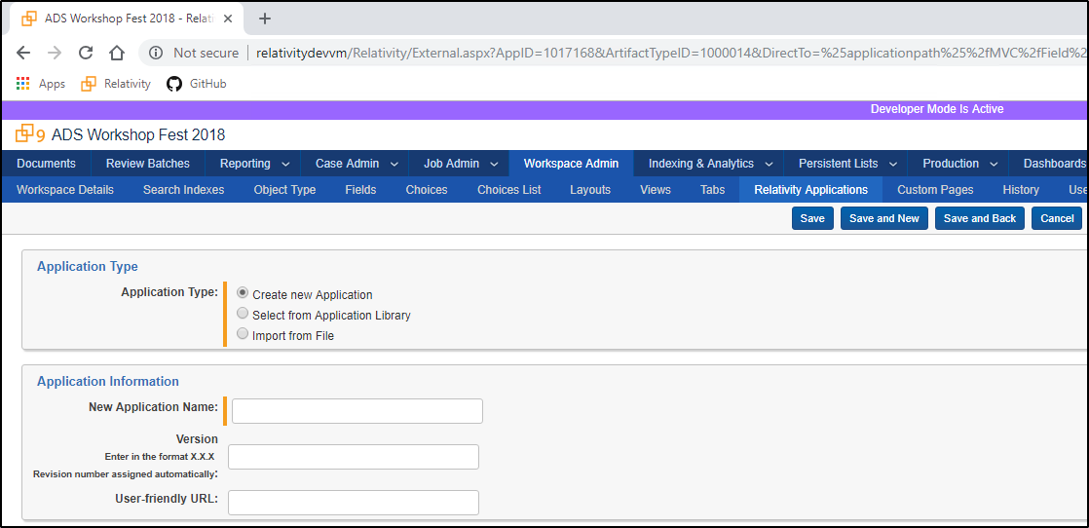

1. Create a new **Object Type** to the application from the view page. This auto-associates the objects initial views, fields, and layouts.

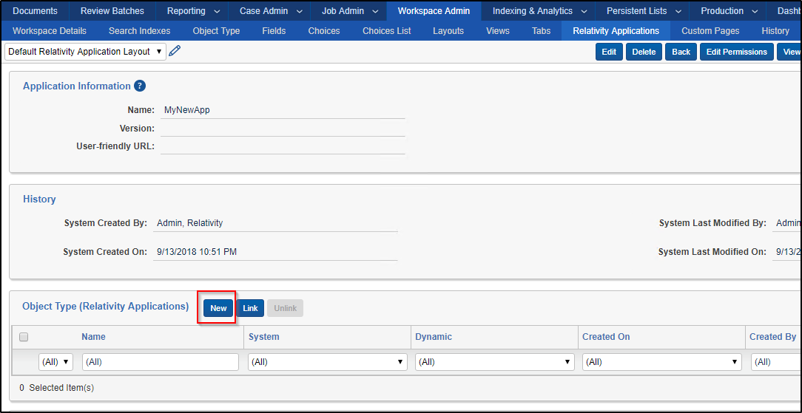

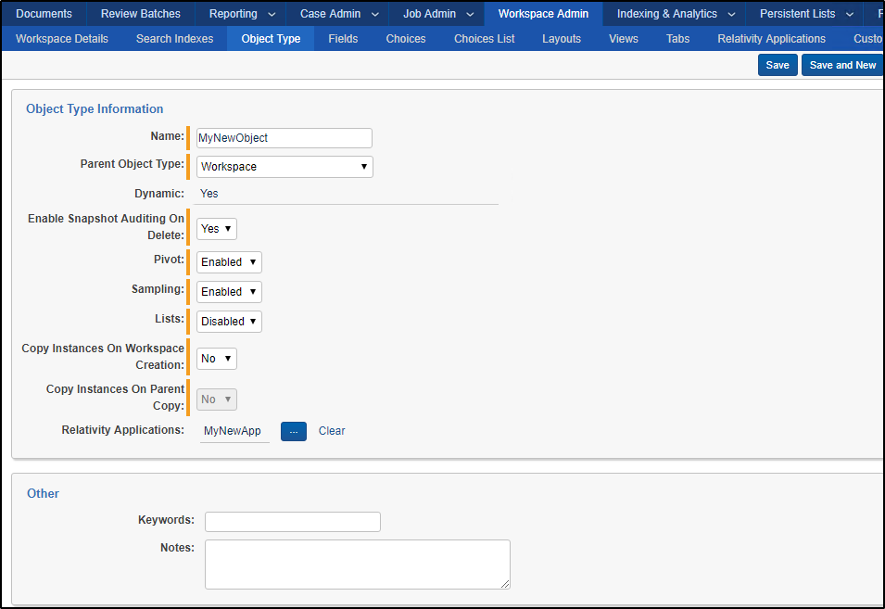

3.2 New Event Handler

1. Open the Visual Studio solution **AdsWorkshopFest2018.sln** in the **E:\Github\ads-workshop-fest-2018\Projects\Starting\1_Templates\Project** folder.

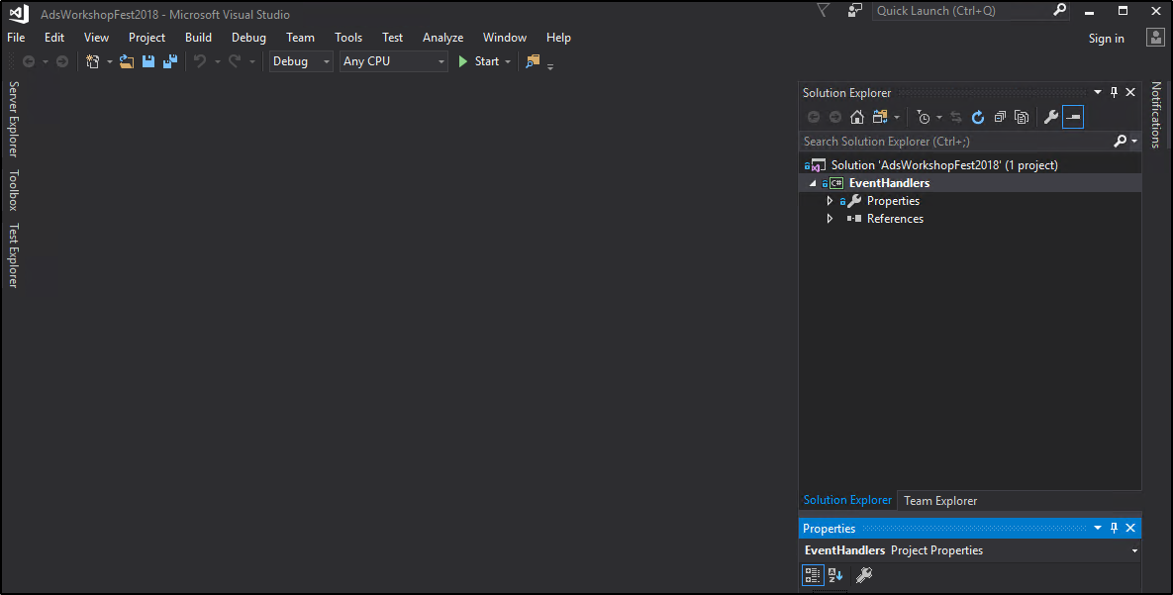

1. Verify the **Relativity Templates** are installed. You may need to **restart** Visual Studio.
2. **Tools** — **Extensions and Updates** — Search "**Relativity**"

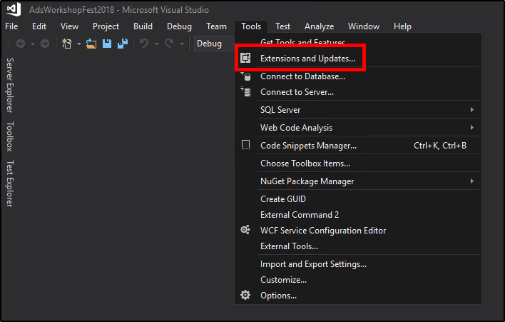

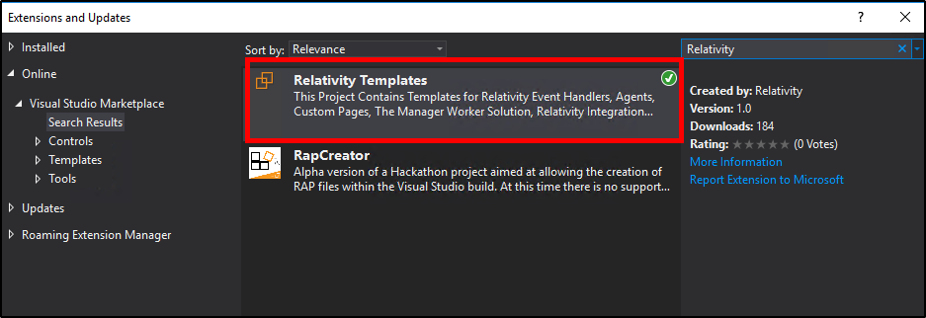

1. Right click the **EventHandlers** Project in the solution explorer. Select Add — **New Item**.

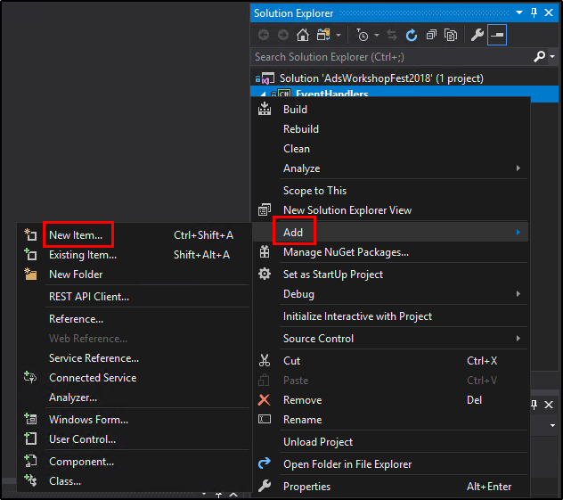

1. Under the Relativity Section, select the **pre-save event handler template.**

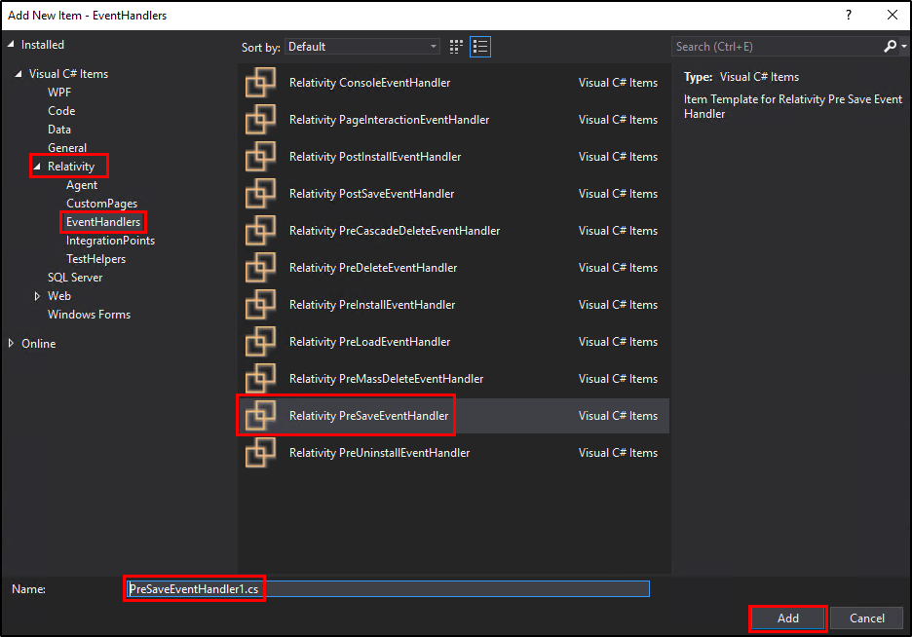

1. Click **Add**.
2. Install the 9.6.134.78 **Relativity.EventHandler** NuGet package.
   1. Right click on the Project.
   2. Select **Manage Nuget Packages** option.

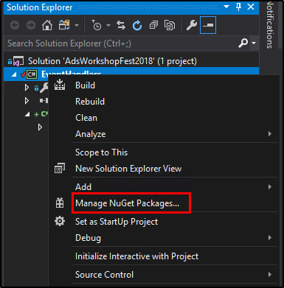

* 1. Switch to **Browse** tab.
  2. Search for “**Relativity**”.
  3. Select the **Relativity.EventHandler** NuGet package.

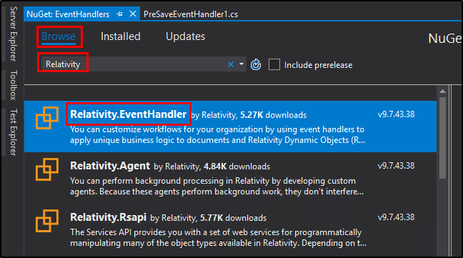

* 1. From the **Version** drop-down select the **9.6.134.78** option.
  2. Click **Install**.

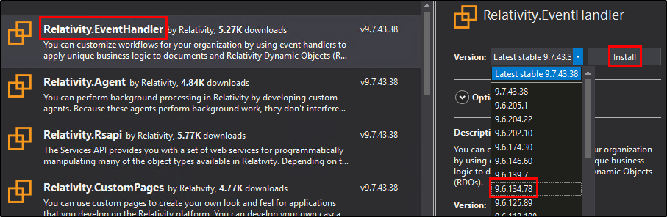

1. Update the event handler response.
   1. *Success* – false
   2. *Message* – Message of your choice

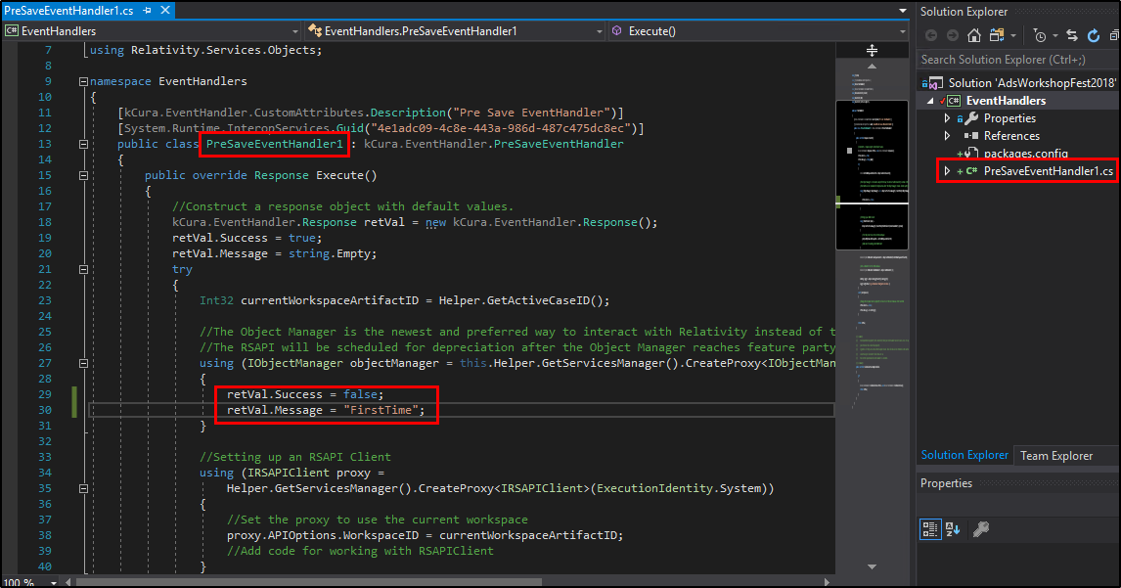

3.3 Publish

1. Build the solution.
2. **Build** — **Build Solution**
3. Run the Publish to Relativity executable.

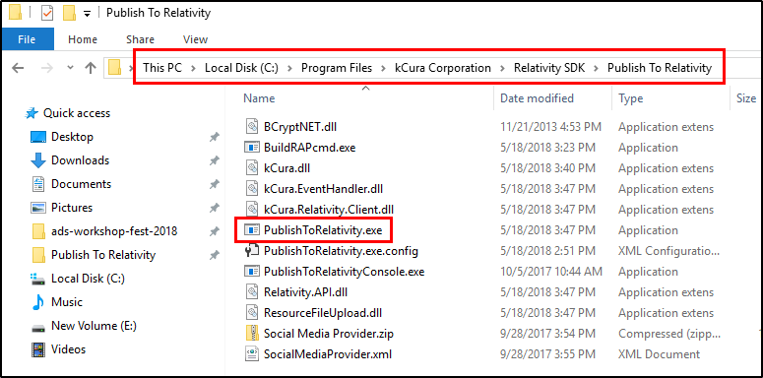

1. Click the **Load Config File** button and select the **TemplatesConfig.xml** file in the **E:\Github\ads-workshop-fest-2018\Projects\Starting\1_Templates** folder.

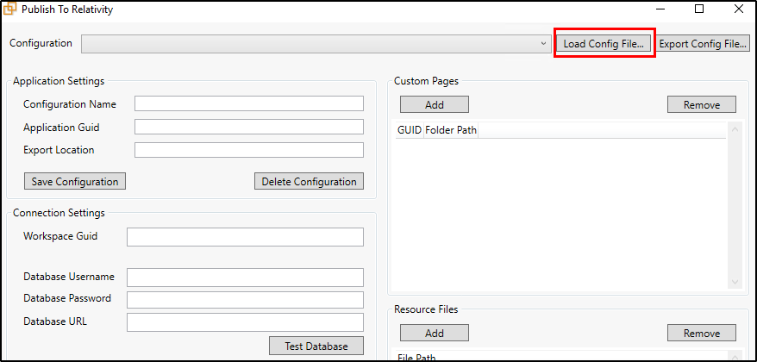

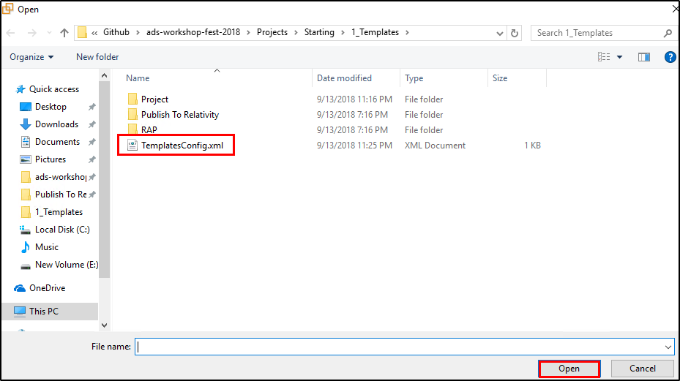

1. Enter the **Relativity Password** (Test1234!).
2. Click on **Test Connections** to validate the connections.
3. Replace the **Application GUID** with your applications GUID.
   1. To look up your applications GUID, navigate back to Relativity Application you created in the workspace. Then select **Show Component GUIDs**.
   2. **Developer Mode** must be active.

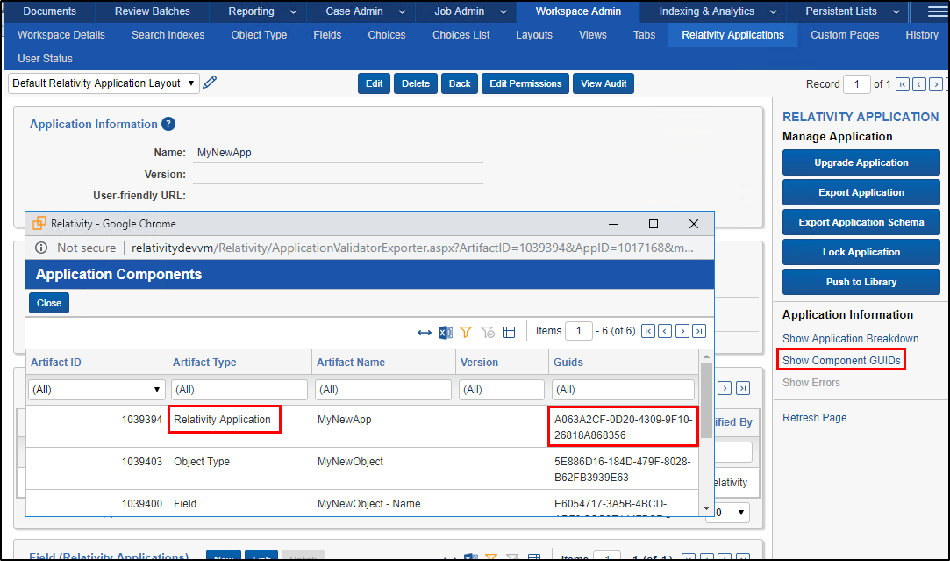

1. In the **Resource Files** Section click Add.
2. Navigate to **E:\Github\ads-workshop-fest-2018\Projects\Starting\1_Templates\Project\EventHandlers\bin\Debug** and select **EventHandlers.dll** file.
3. Click **Publish**.

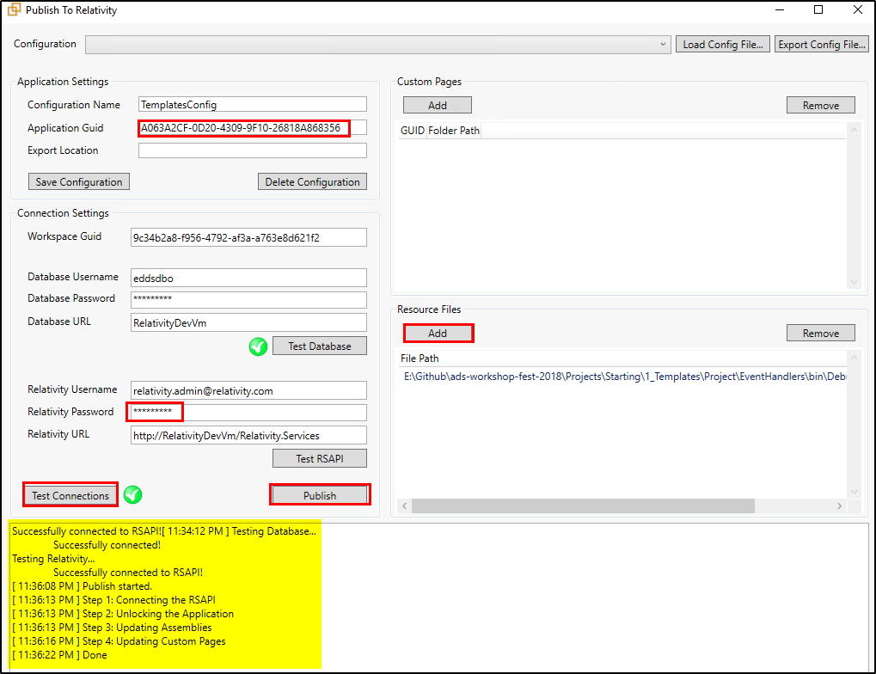

1. Open Relativity and navigate to your application created in section 3.1.
2. **Unlock** the application.

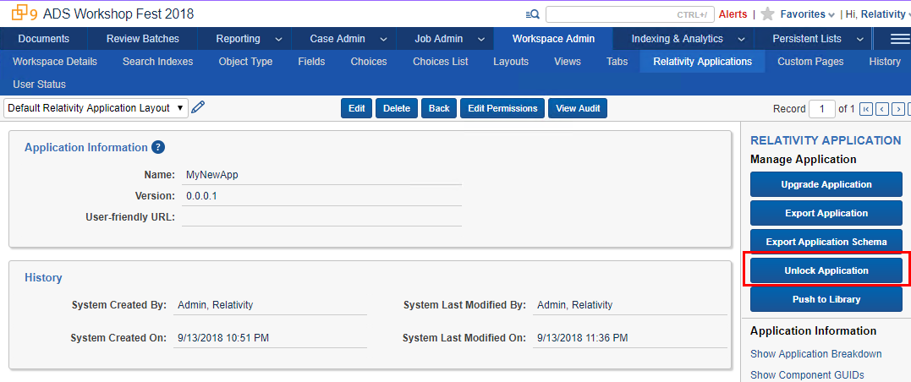

1. Navigate to the view page of the object type created in section 3.1.

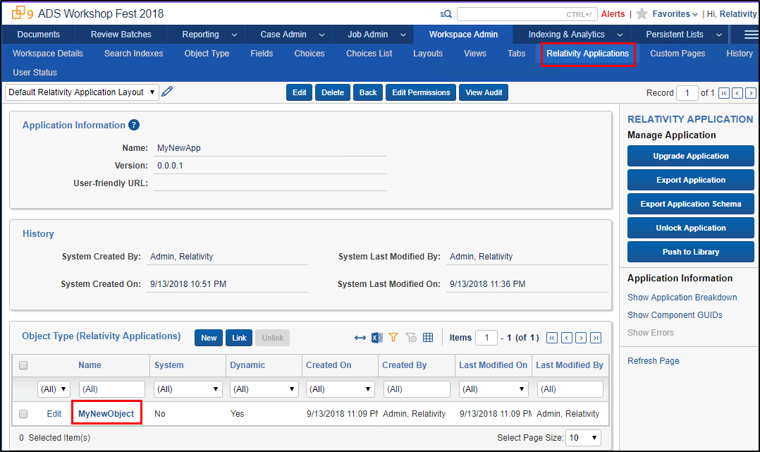

1. Click **New** on the Event handler associated item list.

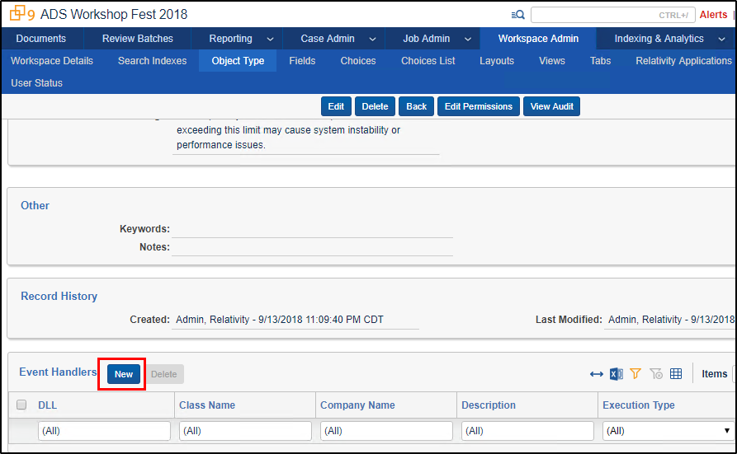

1. Find the newly created Event Handler associated to your application.
   1. Filter by Application Name.
   2. Select it from the list and click **Ok**.

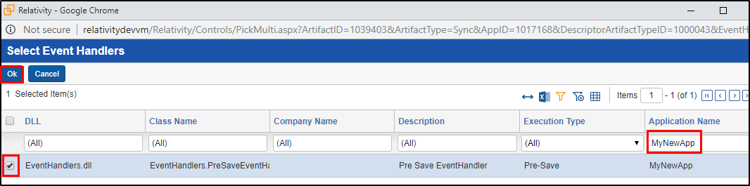

1. Test your event handler by creating a new instance of your object type.

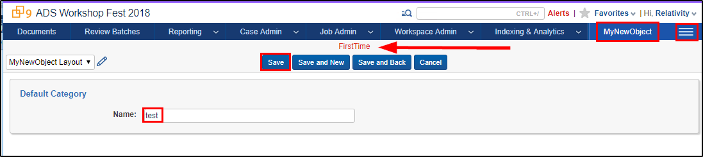

1. Sample Application Overview

The functionality of the Sample Relativity application (ADS Workshop Fest 2018) is to calculate the selected Instance metrics and write them to the Instance Metrics Job.

The ADS Workshop Fest 2018 Relativity application consists of the following:

* **Custom Object**
  + Instance Metrics Job
    - Fields
      * Metrics
      * Status
      * Workspaces Count
      * Users Count
      * Groups Count
      * Errors
* **Event Handler**
  + PreSaveStatusUpdate
* **Agent**
  + Instance Metrics Calculator Agent

4.1 Install Sample Application

1. Go to the **Application Library** tab.
2. Click on the **Upload Application** button

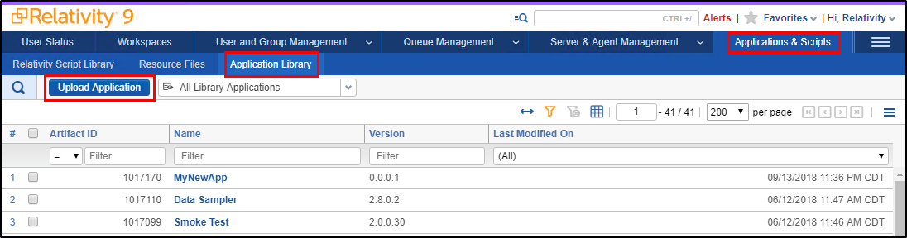

1. Click on **Choose File** button.
2. Navigate to **E:\Github\ads-workshop-fest-2018\Projects\Starting\2_Application\RAP** folder and select the **ADS_Workshop_Fest_2018.rap** file.

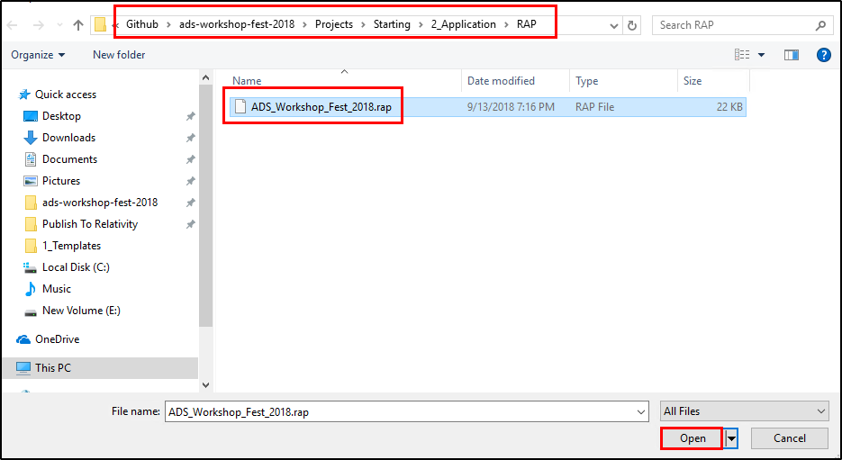

1. Click the **Save** button.
2. Under the **Workspaces Installed** section, click the **Install** button.
3. Select the **ADS Workshop Fest 2018** workspace and click the **Save** button.

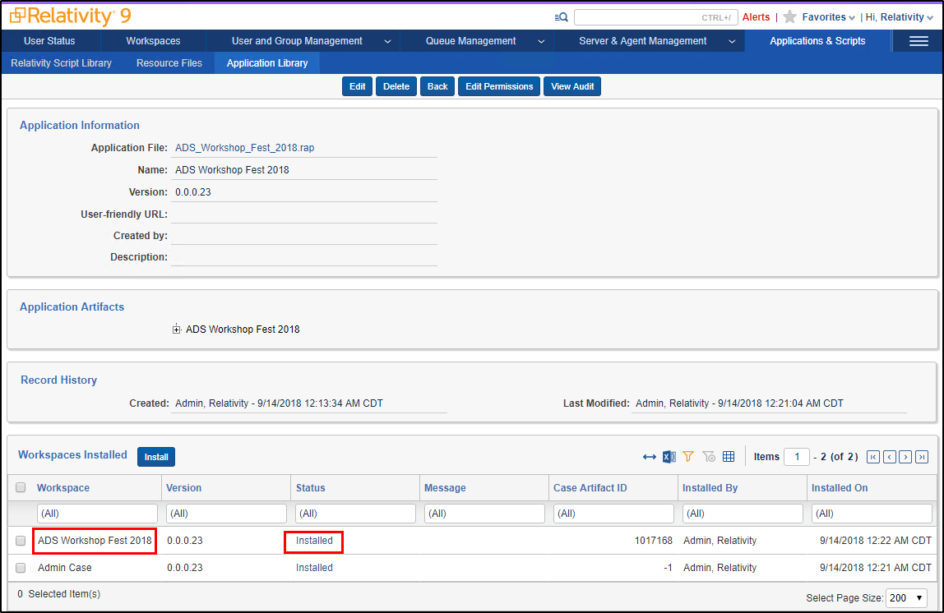

4.2 Run Sample Application

1. Once the application is installed, navigate to the **Agents** tab and create an **Instance Metrics Calculator Agent** agent.

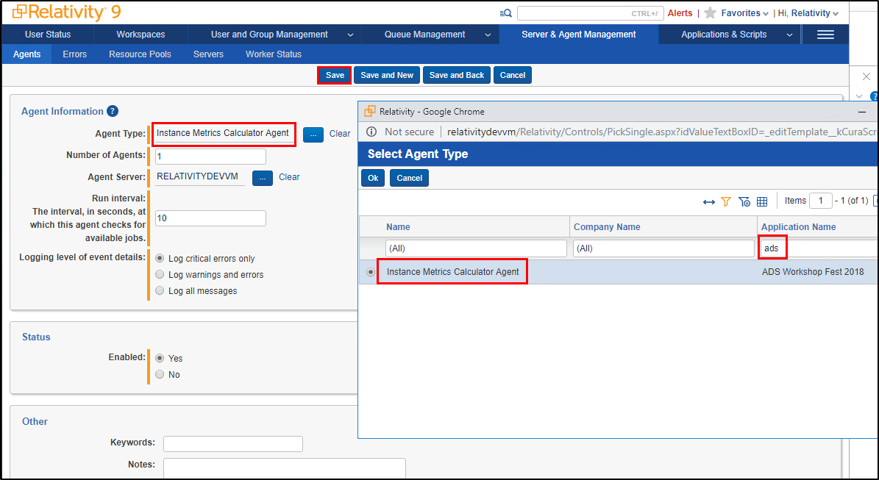

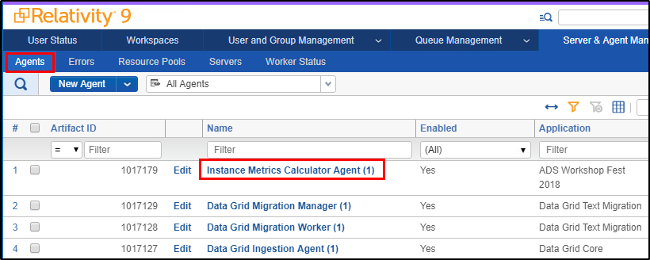

1. Now navigate the **Instance Metrics Job** tab in **ADS Workshop Fest 2018** workspace.
2. Create a new **Instance Metrics Job** and click on the **Save** button.

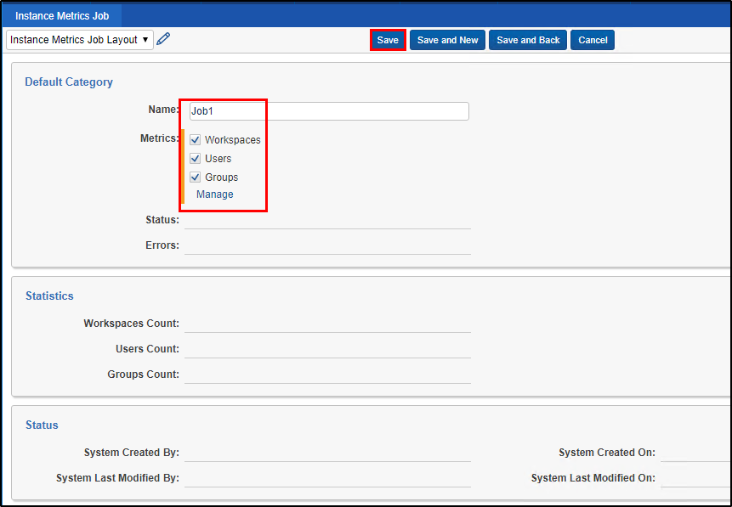

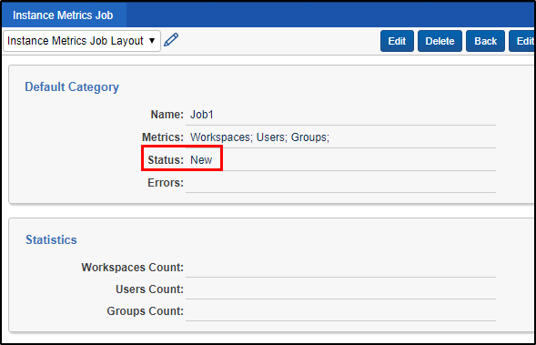

1. The **Instance Metrics Calculator Agent** which is running every 10 seconds will pick up the job and calculate the metrics and save it to the job.
2. Keeping refreshing the windows every few seconds until the job status is set to **Completed**.

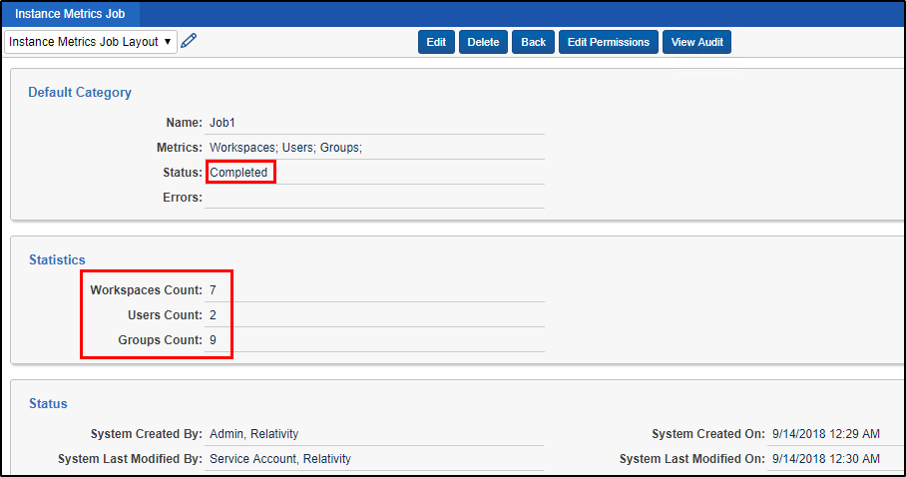

1. Unit Tests

5.1 Writing Unit Tests

1. Navigate to the **E:\Github\ads-workshop-fest-2018\Projects\Starting\3_UnitTests\Project** folder and open **AdsWorkshopFest2018.sln** file.
2. In this solution, you will find 4 projects.
   1. Agents
   2. EventHandlers
   3. Helpers
   4. Helpers.Tests.Unit
3. In this section we will be working in the **Helpers.Tests.Unit** project.
4. In **Helpers** project, there is an **RsapiHelper.cs** file which contains RSAPI calls used in the sample application.
5. Our goal for this section is to write couple unit tests for the **RetrieveJobsInWorkspaceWithStatus** in **RsapiHelper** class.
6. Right click on the solution and select **Manage NuGet Packages for Solution** option.

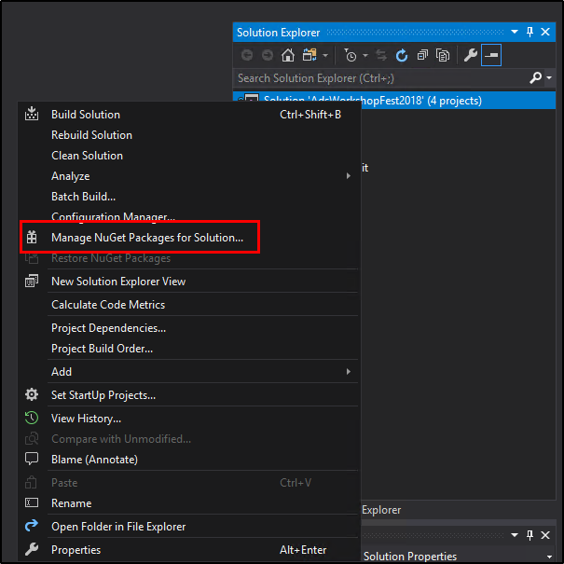

1. Next click the **Restore** button.

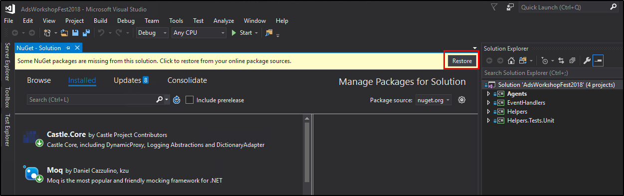

1. Now all the NuGet packages in the solution should be restored.
2. Right click on the **Helpers.Tests.Unit** project and add a new class named **RsapiHelperTests.cs**.
3. Overwrite the default class structure with the Unit Test structure we will be using.
4. Copy and paste code from **"E:\Github\ads-workshop-fest-2018\Projects\Starting\3_UnitTests\TextFiles\1_Structure.txt"** file replacing the entire **RsapiHelperTests.cs** class.

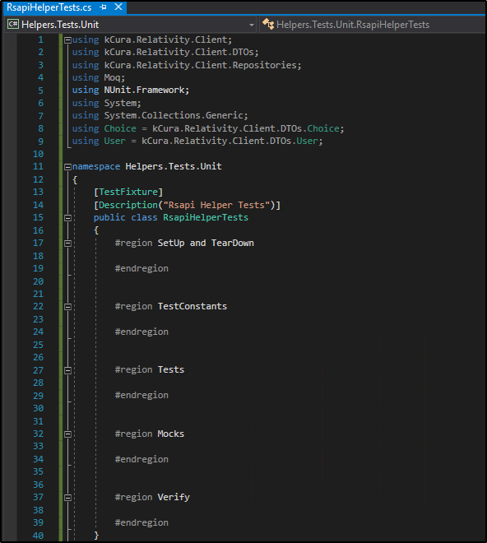

1. Add the RsapiHelper class reference which we will be our System under Test (SUT) for which we are writing unit tests.
2. Copy and paste code from **"E:\Github\ads-workshop-fest-2018\Projects\Starting\3_UnitTests\TextFiles\2_System_Under_Test.txt"** file at the beginning of the **RsapiHelperTests.cs** class.

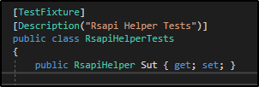

1. Next add the Mocks for various RDO repositories which are used in the Relativity application.
2. Copy and paste code from **"E:\Github\ads-workshop-fest-2018\Projects\Starting\3_UnitTests\TextFiles\3_Mocks.txt"** file at the beginning of the **RsapiHelperTests.cs** class.

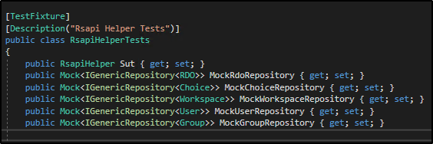

1. Next add the SetUp and TearDown methods which run once before and after all the tests execution.
2. The SetUp method is utilized to inititalize any data needed by tests.
3. The TearDown method is utilized to clean up the data used by the tests.
4. Copy and paste code from **"E:\Github\ads-workshop-fest-2018\Projects\Starting\3_UnitTests\TextFiles\4_SetUp_And_TearDown.txt"** file under the **SetUp and TearDown** region in the **RsapiHelperTests.cs** class.

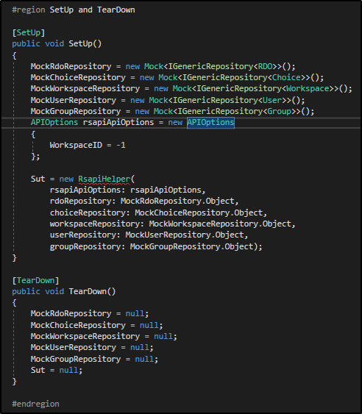

1. Next add the Test constants used in the Tests.
2. Copy and paste code from **"E:\Github\ads-workshop-fest-2018\Projects\Starting\3_UnitTests\TextFiles\5_Test_Constants.txt"** file under the **TestConstants** region in the **RsapiHelperTests.cs** class.

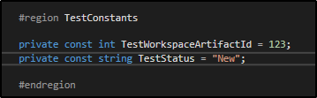

1. Next add the Mock Stubs for an RSAPI call used in the Tests. Here we will be stubbing out the Query method on the RDO repository in RSAPI.
2. Copy and paste code from **"E:\Github\ads-workshop-fest-2018\Projects\Starting\3_UnitTests\TextFiles\6_Mock_Stub_Golden_Flow.txt"** file under the **Mocks** region in the **RsapiHelperTests.cs** class.

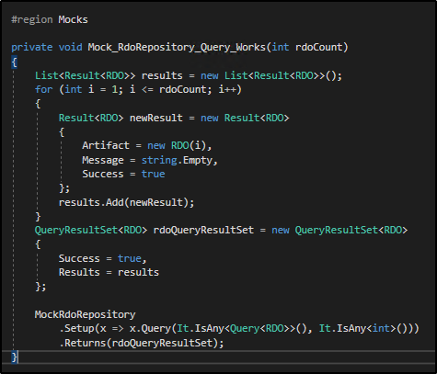

1. Next add the Verify method for the previously added Mock Stubs. Use this method we can verify if our stub was called during our test execution.
2. Copy and paste code from **"E:\Github\ads-workshop-fest-2018\Projects\Starting\3_UnitTests\TextFiles\7_Mock_Stub_Golden_Flow_Verify.txt"** file under the **Verify** region in the **RsapiHelperTests.cs** class.

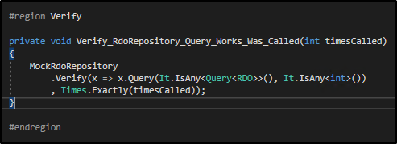

1. Next add the Golden flow test.
2. Copy and paste code from **"E:\Github\ads-workshop-fest-2018\Projects\Starting\3_UnitTests\TextFiles\8_UnitTest_Golden_Flow.txt"** file under the **Tests** region in the **RsapiHelperTests.cs** class.

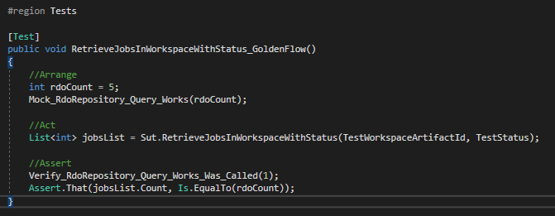

1. Next add the Mock Stubs for an RSAPI call to simulate an exception in the RSAPI call.
2. Copy and paste code from **"E:\Github\ads-workshop-fest-2018\Projects\Starting\3_UnitTests\TextFiles\9_Mock_Stub_Rsapi_Fails.txt"** file under the **Mocks** region in the **RsapiHelperTests.cs** class.

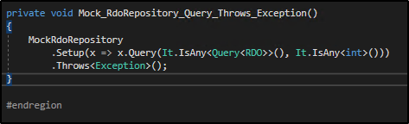

1. Next add the RSAPI Failure test.
2. Copy and paste code from **"E:\Github\ads-workshop-fest-2018\Projects\Starting\3_UnitTests\TextFiles\10_UnitTest_Rsapi_Fails.txt"** file under the **Tests** region in the **RsapiHelperTests.cs** class.

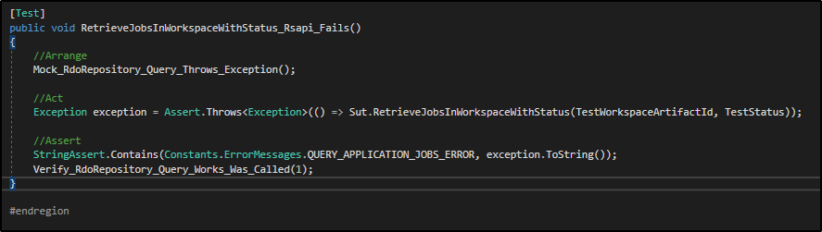

5.2 Running Unit Tests

1. Build the solution to successfully build all the projects.
2. Open the **Test Explorer** by click on the **Test Explorer** tab on the left side bar of Visual Studio.
3. Click on the **Run All** link to run the 2 unit tests we just created.

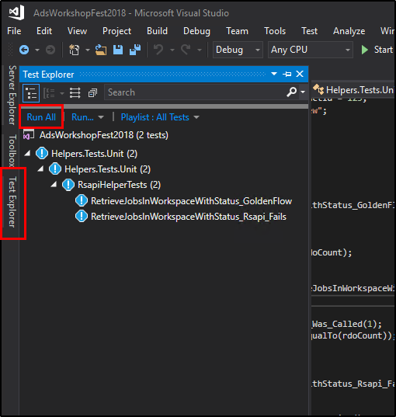

1. On successful run, click on the **Test Explorer** to see the status of the tests. Both the tests should be green.

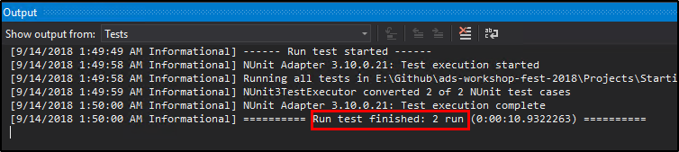

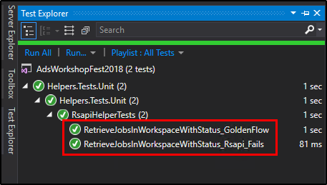

1. Integration Tests

6.1 Writing Integration Tests

1. Navigate to the **E:\Github\ads-workshop-fest-2018\Projects\Starting\4_IntegrationTests\Project** folder and open **AdsWorkshopFest2018.sln** file.
2. In this solution, you will find 4 projects.
   1. Agents
   2. Agents.Tests.Integration
   3. EventHandlers
   4. Helpers
3. In this section we will be working in the **Agents.Tests.Integration** project.
4. Right click on the solution and select **Manage NuGet Packages for Solution** option.



1. Next click the **Restore** button.

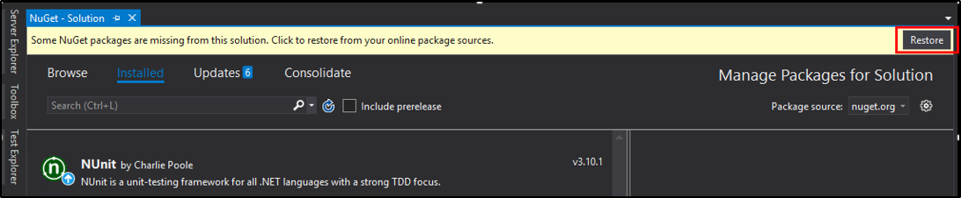

1. Now all the NuGet packages in the solution should be restored.
2. Right click on the **Agents.Tests.Integration** project and add a new class named **AgentsTests.cs**.
3. Overwrite the default class structure with the Integration Test structure we will be using.
4. Copy and paste code from **"E:\Github\ads-workshop-fest-2018\Projects\Starting\4_IntegrationTests\TextFiles\1_Structure.txt"** file replacing the entire **AgentsTests.cs** class.

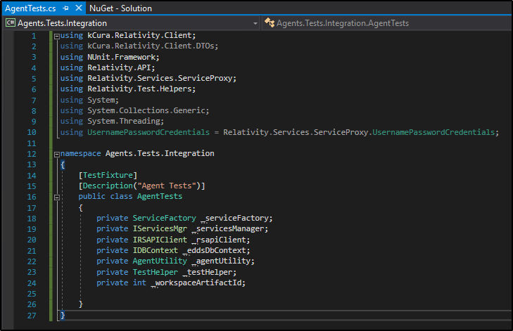

1. Add the **OneTimeSetUp** method and its dependent methods to the **AgentsTests** class.
2. Copy and paste code from **"E:\Github\ads-workshop-fest-2018\Projects\Starting\4_IntegrationTests\TextFiles\2_OneTimeSetUp.txt"** to the **AgentsTests** class.

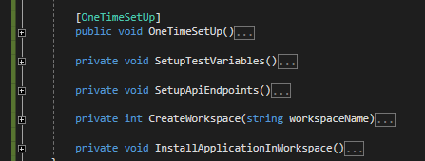

1. Add the **OneTimeTearDown** method and its dependent methods to the **AgentsTests** class.
2. Copy and paste code from **"E:\Github\ads-workshop-fest-2018\Projects\Starting\4_IntegrationTests\TextFiles\3_OneTimeTearDown.txt"** to the **AgentsTests** class.

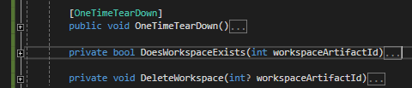

1. Add the **Job_ShouldBePickedUp_WhenStatusIsSetToNew_And_RunSuccessfully** integration test method and its dependent methods to the **AgentsTests** class.
2. Copy and paste code from **"E:\Github\ads-workshop-fest-2018\Projects\Starting\4_IntegrationTests\TextFiles\4_Job_ShouldBePickedUp_WhenStatusIsSetToNew_And_RunSuccessfully.txt"** to the **AgentsTests** class.

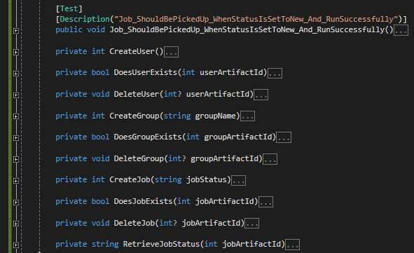

1. Add the **Job_ShouldNotBePickedUp_WhenStatusIsNotSetToNew** integration test method and its dependent methods to the **AgentsTests** class.
2. Copy and paste code from **"E:\Github\ads-workshop-fest-2018\Projects\Starting\4_IntegrationTests\TextFiles\5_Job_ShouldNotBePickedUp_WhenStatusIsNotSetToNew.txt"** to the **AgentsTests** class.



6.2 Running Integration Tests

1. Open **TestConstants.cs** file in **Agents.Tests.Integration** project.
2. Replace the **192.168.137.95** IP address with the DevVM machine name (**RelativityDevVm**).

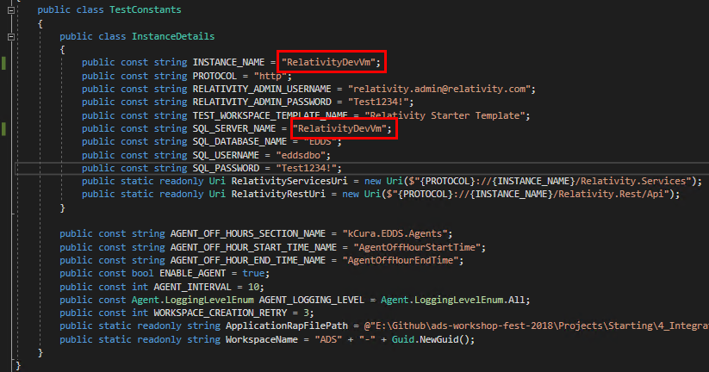

1. Open **App.config** file in **Agents.Tests.Integration** project.
2. Replace the **192.168.137.95** IP address with the DevVM machine name (**RelativityDevVm**).

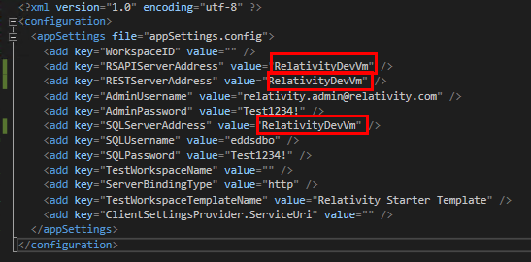

1. Build the solution to successfully build all the projects.
2. Open the **Test Explorer** by click on the **Test Explorer** tab on the left side bar of Visual Studio.
3. Click on the **Run All** link to run the 2 unit tests we just created.

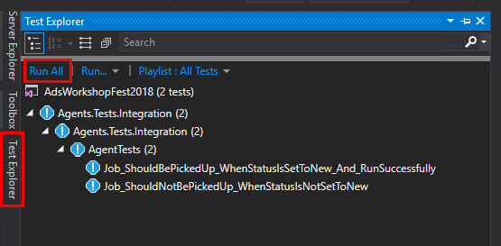

1. On successful run, click on the **Test Explorer** to see the status of the tests. Both the tests should be green.

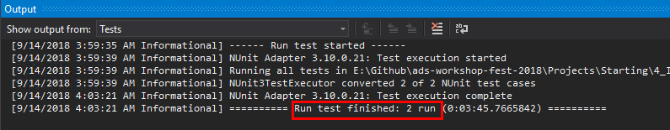

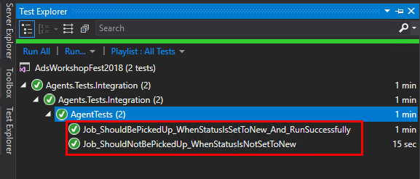

6.2 Running Integration Tests as CI

1. Open the **E:\Github\ads-workshop-fest-2018\Projects\Starting\4_IntegrationTests\CI_Scripts** folder
2. Here you will find 3 files and 1 folder which we will be using to run Integration Tests as a CI (Continuous Integration) process.
3. Copy all the files and folders from the CI_Scripts folder to **E:\Github\ads-workshop-fest-2018\Projects\Starting\4_IntegrationTests\Project** folder.

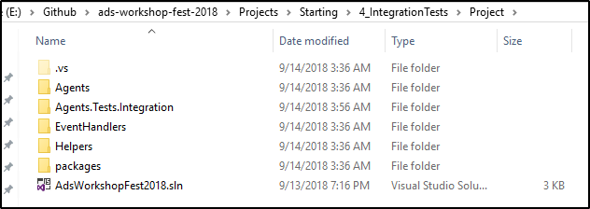

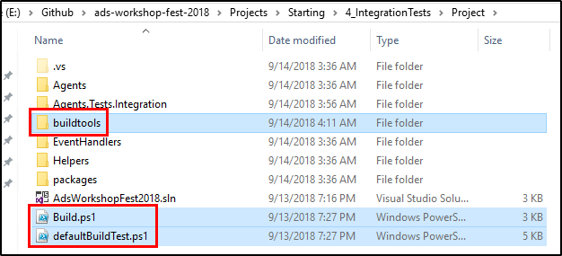

1. Open the **Build.ps1** script and update the **NuGet_URL** to use the one which is compatible with Visual Studio 2017.

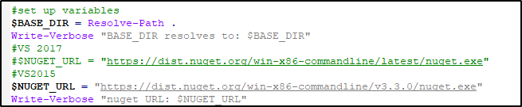

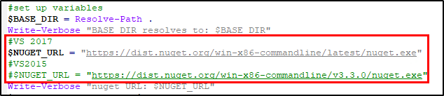

1. Open the **defaultBuildTest.ps1** script and update the **project paths.**
   1. Replace line 10 with the following code.

**Code:**

$solution = Join-Path $root "..\AdsWorkshopFest2018.sln"

**Before:**



**After:**



* 1. Replace line 15 with the following code.

**Code:**

$testAssembly = $testAssembly = Join-Path $root "..\Project\Agents.Tests.Integration\bin\Debug\Agents.Tests.Integration.dll"

**Before:**



**After:**



* 1. Comment lines 64 – 66.



* 1. Replace lines 69 - 74 with the following code.

**Code:**

$testDir = Join-Path $root "..\Agents.Tests.Integration"

$testDir = Join-Path $root "..\Agents.Tests.Integration"

$configSource = "..\Project\Agents.Tests.Integration\App.config"

Write-Host "configSource is : $configSource"

$configDestination = Join-Path $root "..\Project\Agents.Tests.Integration\bin\Debug\Agents.Tests.Integration.dll.config"

Write-Host "Test assembly : $testAssembly"

Copy-Item $configSource $configDestination -Verbose:$VerbosePreference

**Before:**

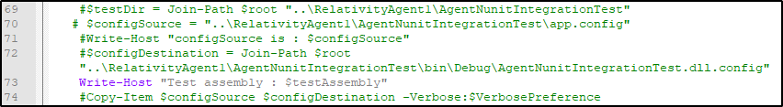

**After:**

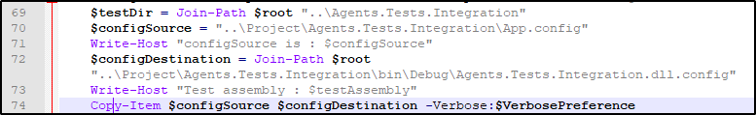

1. Open PowerShell and run the following command.

Set-ExecutionPolicy Unrestricted

1. When prompted type **A** and press **Enter**.
2. Close the current PowerShell window and open a new PowerShell window.
3. Navigate to **“E:\Github\ads-workshop-fest-2018\Projects\Starting\4_IntegrationTests\Project”** folder by running the following command.

cd E:\Github\ads-workshop-fest-2018\Projects\Starting\4_IntegrationTests\Project

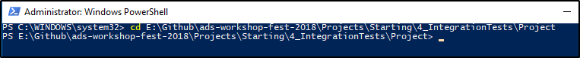

1. Run the following command to run the Integration Tests.

.\Build.ps1 IntegrationTest



1. You will see the following output when the Integration tests are run successfully.

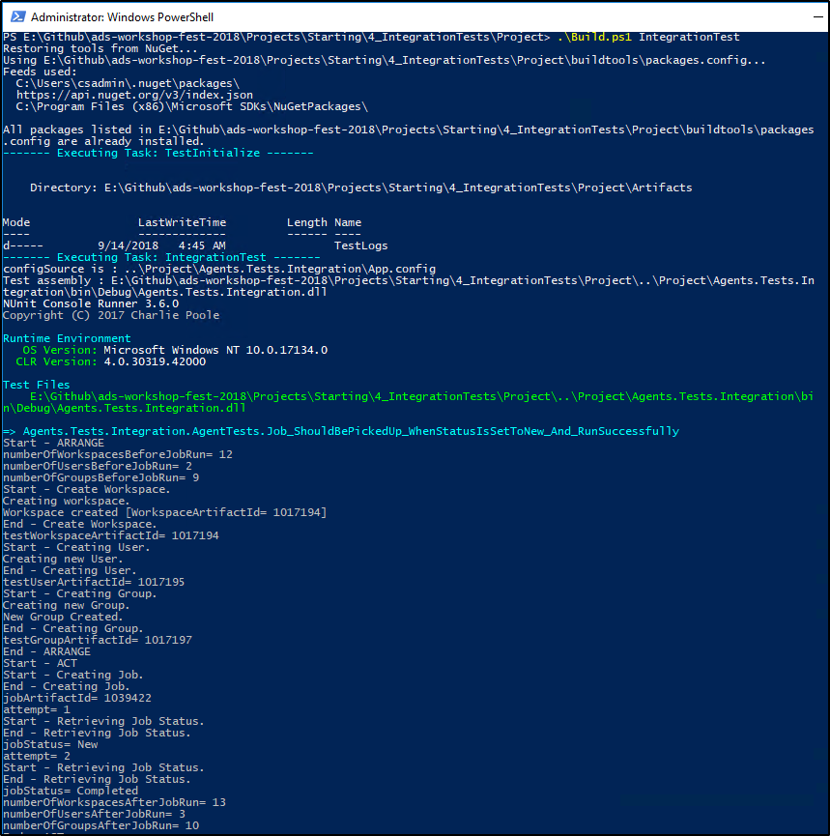

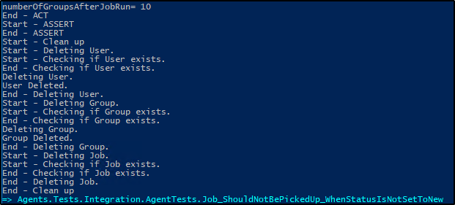

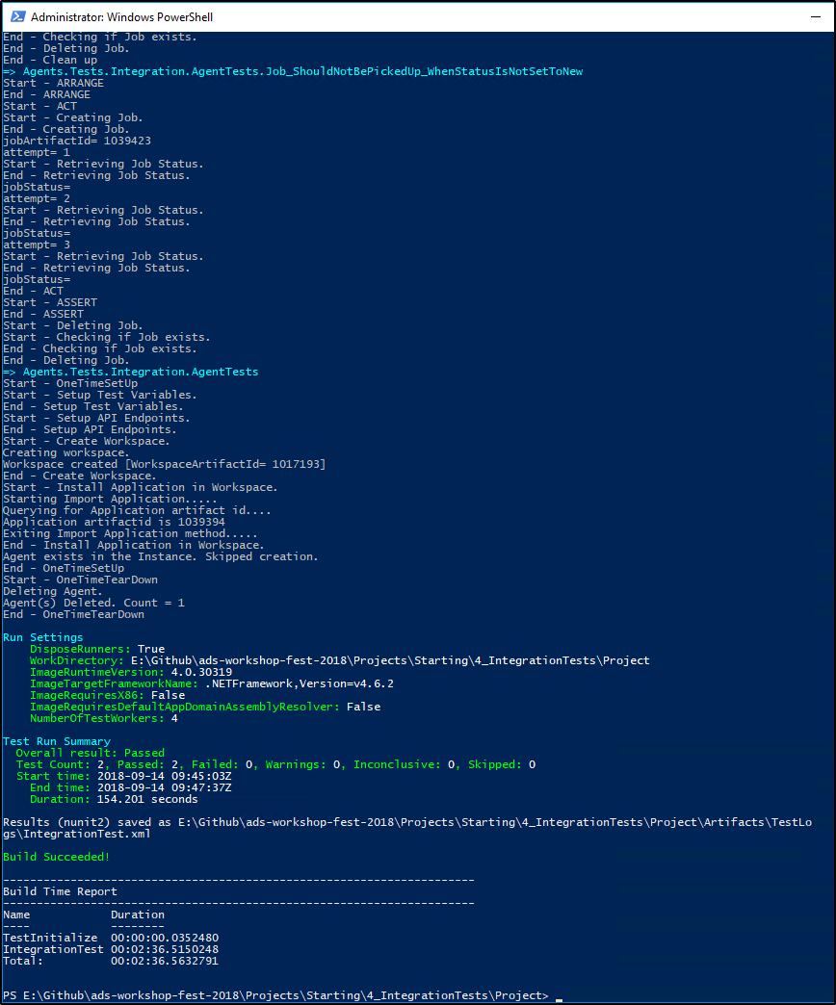

1. Gravity API
2. In this section, we will be using the Gravity open source API instead of RSAPI to read and update RDO values. You can read more about the Gravity API at this link: [**https://github.com/relativitydev/Gravity**](https://github.com/relativitydev/Gravity)
3. To use the **Gravity** API, first go to Visual Studio and add Gravity.dll as new reference for **Helpers** project and **Agents** project. You can find Gravity.dll in **ads-workshop-fest-2018\Files\Gravity**

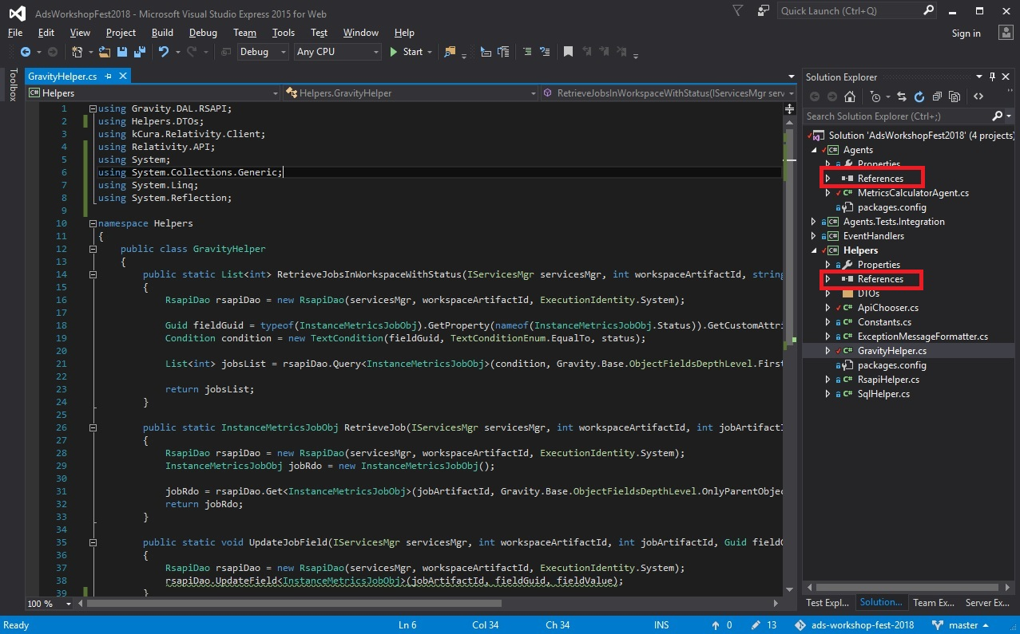

1. To use the **Gravity** API, first go to Visual Studio and create enum MetricsChoices under folder DTOs in Helpers project. This enum represents the Choices for Metrics field.

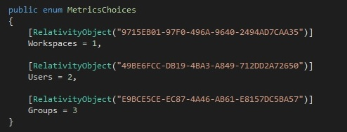

**Code to add:**

public enum MetricsChoices

{

[RelativityObject("9715EB01-97F0-496A-9640-2494AD7CAA35")]

Workspaces = 1,

[RelativityObject("49BE6FCC-DB19-4BA3-A849-712DD2A72650")]

Users = 2,

[RelativityObject("E9BCE5CE-EC87-4A46-AB61-E8157DC5BA57")]

Groups = 3

}

1. Then create class for the RDO with its fields as properties under folder DTOs in Helpers project.

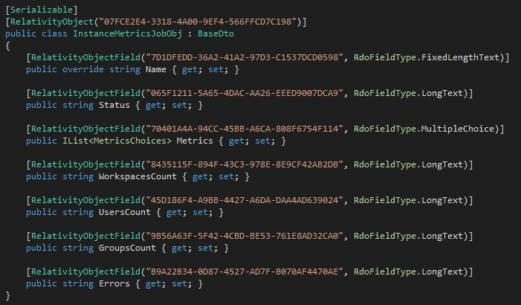

**Code to add:**

using Gravity.Base;

using System;

using System.Collections.Generic;

namespace Helpers.DTOs

{

[Serializable]

[RelativityObject("07FCE2E4-3318-4A00-9EF4-566FFCD7C198")]

public class InstanceMetricsJobObj : BaseDto

{

[RelativityObjectField("7D1DFEDD-36A2-41A2-97D3-C1537DCD0598", RdoFieldType.FixedLengthText)]

public override string Name { get; set; }

[RelativityObjectField("065F1211-5A65-4DAC-AA26-EEED9007DCA9", RdoFieldType.LongText)]

public string Status { get; set; }

[RelativityObjectField("70401A4A-94CC-45BB-A6CA-808F6754F114", RdoFieldType.MultipleChoice)]

public IList<MetricsChoices> Metrics { get; set; }

[RelativityObjectField("8435115F-894F-43C3-978E-8E9CF42AB2DB", RdoFieldType.LongText)]

public string WorkspacesCount { get; set; }

[RelativityObjectField("45D186F4-A9BB-4427-A6DA-DAA4AD639024", RdoFieldType.LongText)]

public string UsersCount { get; set; }

[RelativityObjectField("9B56A63F-5F42-4CBD-BE53-761E8AD32CA0", RdoFieldType.LongText)]

public string GroupsCount { get; set; }

[RelativityObjectField("B9A22B34-0D87-4527-AD7F-B070AF4470AE", RdoFieldType.LongText)]

public string Errors { get; set; }

}

}

1. To use Gravity, you have to create RsapiDao. You will see this for the methods below.



1. When you have created the RsapiDao, you can use it for various CRUDQ operations.



1. If you want to retrieve the GUID for a field, you can do that by using Reflection



1. Open the **GravityHelper.cs** file in **Helpers** project and add the following **using** statements

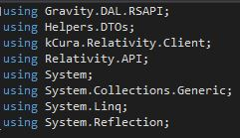

**Code to add:**

using Gravity.DAL.RSAPI;

using Helpers.DTOs;

using kCura.Relativity.Client;

using Relativity.API;

using System;

using System.Collections.Generic;

using System.Linq;

using System.Reflection;

1. Next declare method to retrieve all jobs in a workspace for specific status

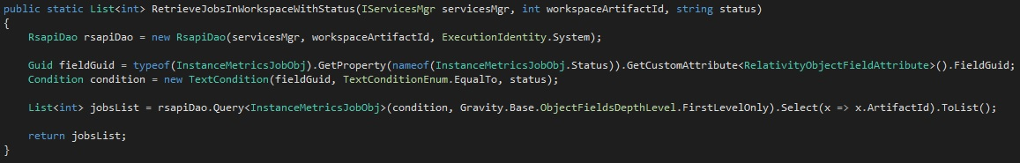

**Code to add:**

public static List<int> RetrieveJobsInWorkspaceWithStatus(IServicesMgr servicesMgr, int workspaceArtifactId, string status)

{

RsapiDao rsapiDao = new RsapiDao(servicesMgr, workspaceArtifactId, ExecutionIdentity.System);

Guid fieldGuid = typeof(InstanceMetricsJobObj).GetProperty(nameof(InstanceMetricsJobObj.Status)).GetCustomAttribute<RelativityObjectFieldAttribute>().FieldGuid;

Condition condition = new TextCondition(fieldGuid, TextConditionEnum.EqualTo, status);

List<int> jobsList = rsapiDao.Query<InstanceMetricsJobObj>(condition, Gravity.Base.ObjectFieldsDepthLevel.FirstLevelOnly).Select(x => x.ArtifactId).ToList();

return jobsList;

}

1. In the same **GravitiyHelper.cs**, declare method to retrieve one specific job

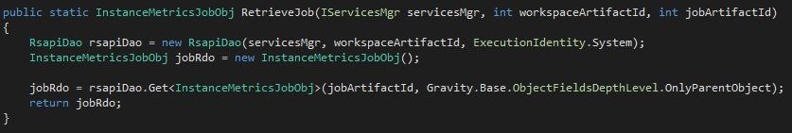

**Code to add:**

public static InstanceMetricsJobObj RetrieveJob(IServicesMgr servicesMgr, int workspaceArtifactId, int jobArtifactId)

{

RsapiDao rsapiDao = new RsapiDao(servicesMgr, workspaceArtifactId, ExecutionIdentity.System);

InstanceMetricsJobObj jobRdo = new InstanceMetricsJobObj();

jobRdo = rsapiDao.Get<InstanceMetricsJobObj>(jobArtifactId, Gravity.Base.ObjectFieldsDepthLevel.OnlyParentObject);

return jobRdo;

}

1. In the same **GravityHelper.cs**, declare method to update specific field

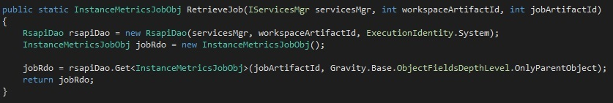

**Code to add:**

public static void UpdateJobField(IServicesMgr servicesMgr, int workspaceArtifactId, int jobArtifactId, Guid fieldGuid, object fieldValue)

{

RsapiDao rsapiDao = new RsapiDao(servicesMgr, workspaceArtifactId, ExecutionIdentity.System);

rsapiDao.UpdateField<InstanceMetricsJobObj>(jobArtifactId, fieldGuid, fieldValue);

}

1. Open the **ApiChooser.cs** file in **Helpers** project and invoke the method **GravityHelper.RetrieveJobsInWorkspaceWithStatus** (declared in step 4) in method public **List<int> RetrieveJobsInWorkspaceWithStatus(IServicesMgr servicesMgr, int workspaceArtifactId, string status)**

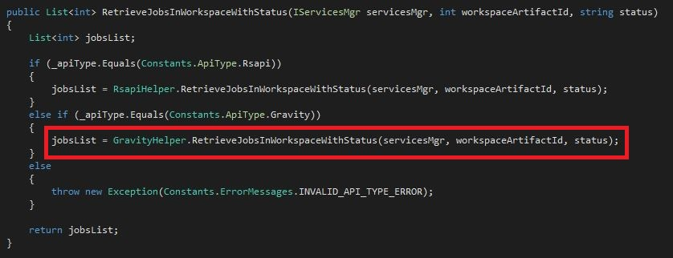

**Code to add:**

jobsList = GravityHelper.RetrieveJobsInWorkspaceWithStatus(servicesMgr, workspaceArtifactId, status);

1. Next, create a method to invoke **GravityHelper.RetrieveJob**

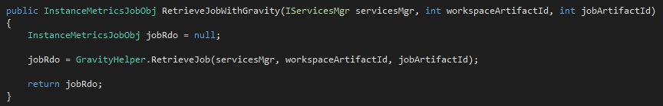

**Code to add:**

public InstanceMetricsJobObj RetrieveJobWithGravity(IServicesMgr servicesMgr, int workspaceArtifactId, int jobArtifactId)

{

InstanceMetricsJobObj jobRdo = null;

jobRdo = GravityHelper.RetrieveJob(servicesMgr, workspaceArtifactId, jobArtifactId);

return jobRdo;

}

1. Now invoke **GravityHelper.UpdateJobField** in method **public void UpdateJobField(IServicesMgr servicesMgr, int workspaceArtifactId, int jobArtifactId, Guid fieldGuid, object fieldValue)**

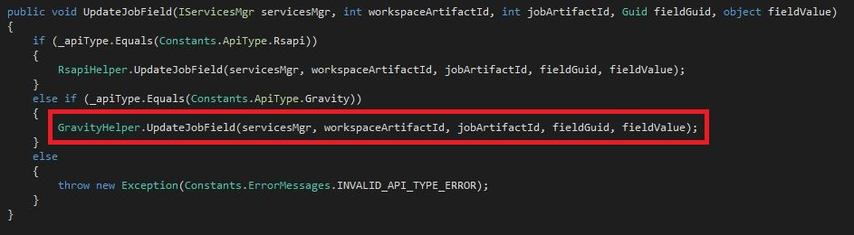

**Code to add:**

GravityHelper.UpdateJobField(servicesMgr, workspaceArtifactId, jobArtifactId, fieldGuid, fieldValue);

1. Now you are ready to use the ApiChooser methods in the Agents project. Go to Agents project and open **MetricsCalculatorAgent.cs**. Create overload method **ProcessAllMetrics(IServicesMgr servicesMgr, int workspaceArtifactId, int jobArtifactId, InstanceMetricsJobObj jobRdo)**.

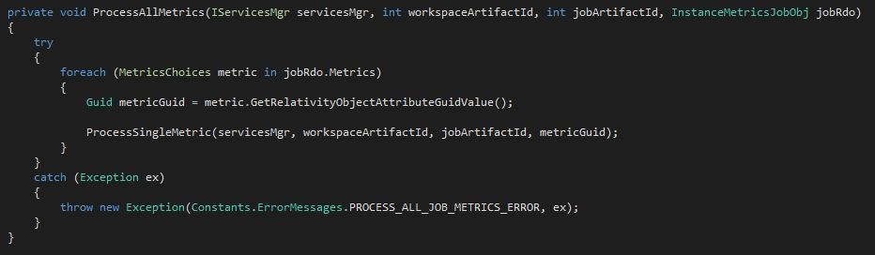

**Code to add:**

private void ProcessAllMetrics(IServicesMgr servicesMgr, int workspaceArtifactId, int jobArtifactId, InstanceMetricsJobObj jobRdo)

{

try

{

foreach (MetricsChoices metric in jobRdo.Metrics)

{

Guid metricGuid = metric.GetRelativityObjectAttributeGuidValue();

ProcessSingleMetric(servicesMgr, workspaceArtifactId, jobArtifactId, metricGuid);

}

}

catch (Exception ex)

{

throw new Exception(Constants.ErrorMessages.PROCESS_ALL_JOB_METRICS_ERROR, ex);

}

}

1. Use RetrieveJobWithGravity to retrieve and process the job in **private void ProcessJob(IServicesMgr servicesMgr, int workspaceArtifactId, int jobArtifactId)**

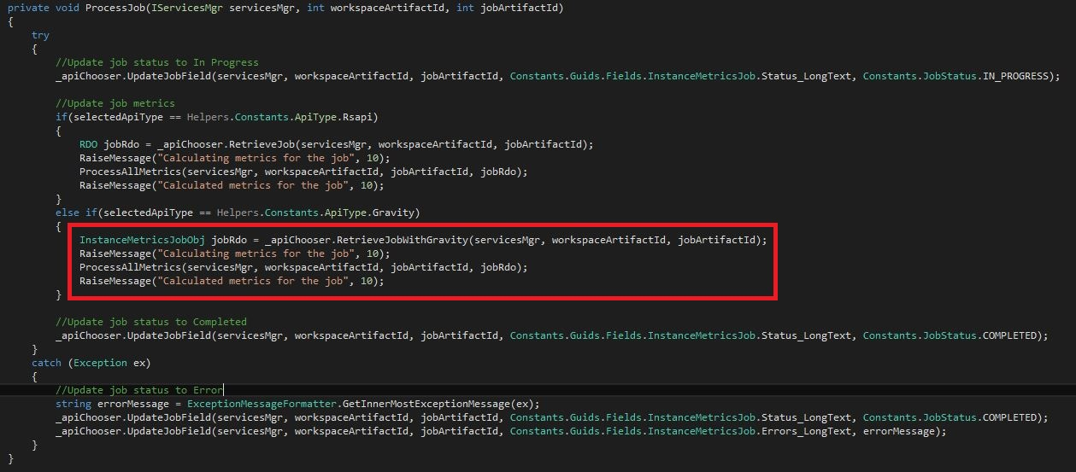

**Code to add:**

InstanceMetricsJobObj jobRdo = _apiChooser.RetrieveJobWithGravity(servicesMgr, workspaceArtifactId, jobArtifactId);

RaiseMessage("Calculating metrics for the job", 10);

ProcessAllMetrics(servicesMgr, workspaceArtifactId, jobArtifactId, jobRdo);

RaiseMessage("Calculated metrics for the job", 10);

1. To switch from RSAPI to Gravity change the field **private static readonly Constants.ApiType selectedApiType** in **MetricsCalculatorAgent.cs**

